**PART 1**

Discrepancies between the parameters in the script downloaded from <https://pubs.acs.org/doi/abs/10.1021/acs.jpclett.6b00452> and those listed in the supplementary information (SI) of the original RSFF2 paper <https://pubs.acs.org/doi/abs/10.1021/jp5064676> :

(1) The ε for the VdW 1–6 interaction between C*γ*...O*i*-1 for Val and Ile, and the *ε* for the VdW 1–5 interaction between C*γ*...O for Val and Ile (2.0 kJ/mol in the SI; 0.2 in the script). (See **Figure 1**)

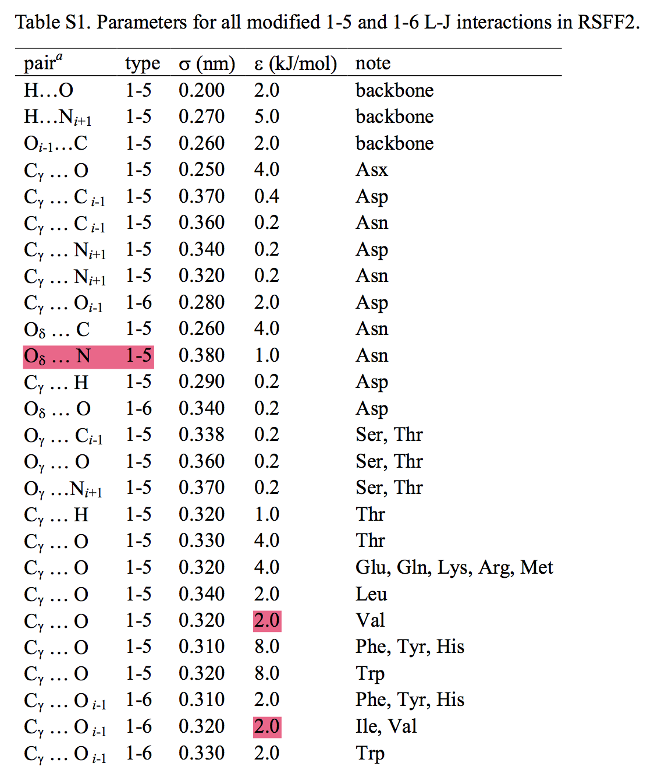

**Figure 1**

(2) This is probably a typo: the 1–5 interaction between O*δ* … N for Asn listed in the SI should be 1–6 interaction between Nδ … O, which is what it is in the script (see **Figure 1**). It is likely a typo because this 1–5 interaction does not show up in Scheme 1D of the main paper (see **Figure 2**), while the 1–6 interaction does. However, another 1–6 interaction between Oδ … O shown in the scheme does not show up in both the SI and script…?

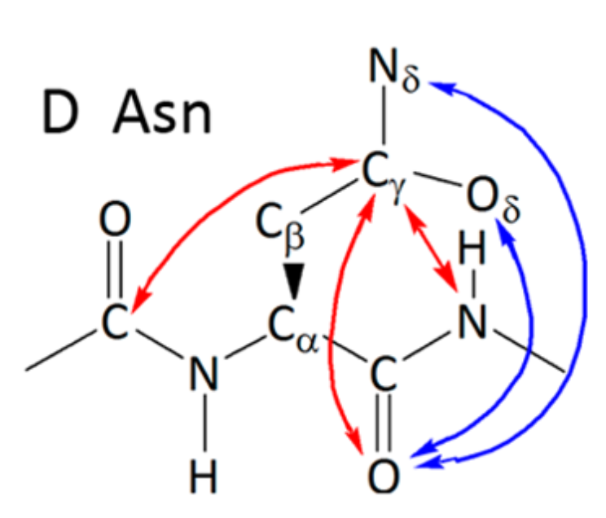

**Figure 2**

(3) Some differences in the *C0* coefficients for *φ*/*φ*'/*ψ*/*ψ*, specifically Gln *φ*/*φ*', HisD *φ*/*φ*', Trp *φ*/*φ*', Val *ψ*/*ψ*', and Ile *ψ*/*ψ*'. These discrepancies shouldn't result in any difference though, given that *C0* is a constant in the potential profile. (See **Figure 3**)

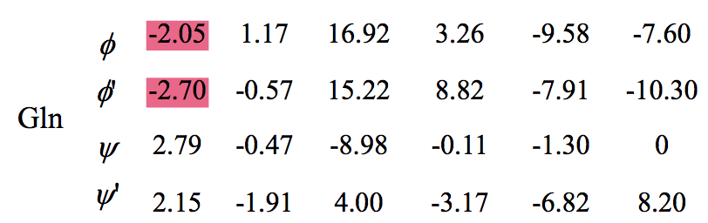

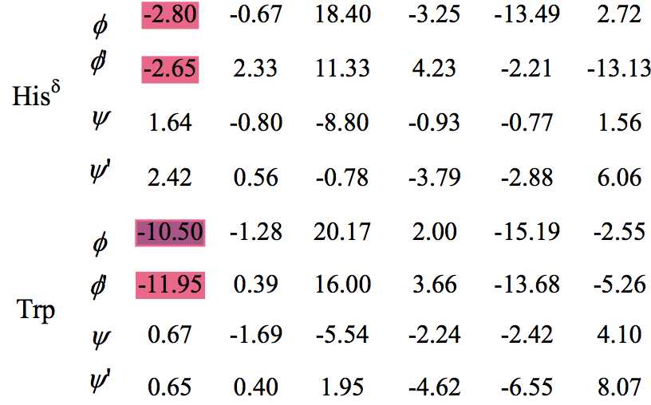

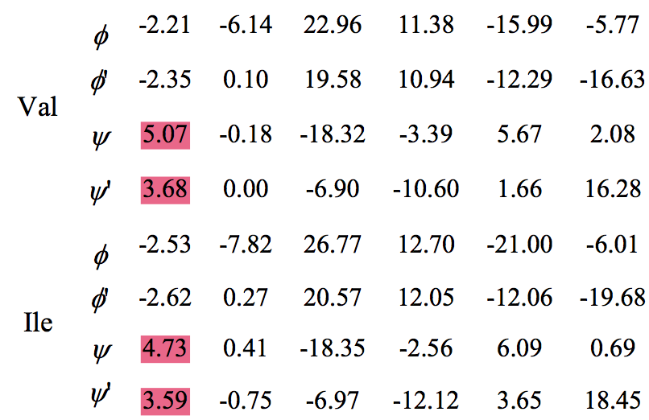

**Figure 3**

(4) There are backbone torsion parameters (*φ*, *φ*', *ψ*, *ψ*') for HisE in the script, while they are not listed in the SI. (See **Figure 4**)

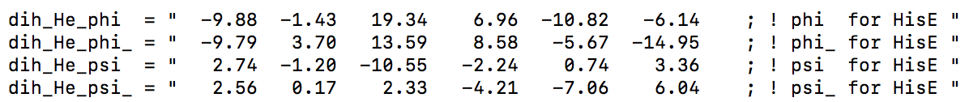

**Figure 4**

(5) Differences in the coefficients of *χ*1 and *χ*1’ angles for Ser, and in the coefficients of *χ*2 angle for His. Also, there’re coefficients of *χ*2’ angle for His in the script, but they are not listed in the SI. (See **Figure 5**)

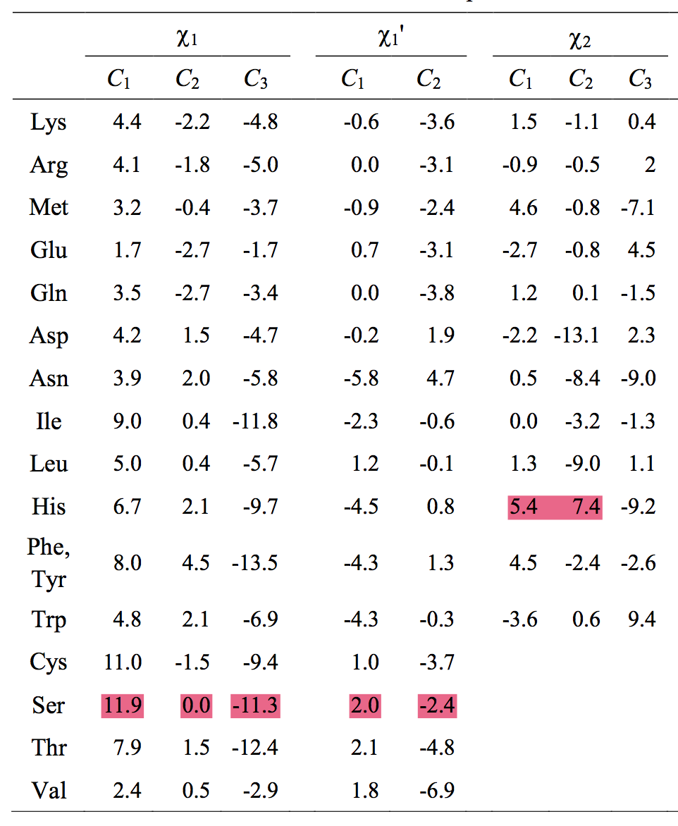

**Figure 5**

(5) The interaction between Cg-O in Leu is modified for both the oxygen in the amino acid and with the previous amino acid

Pair_15.append( (Res_prev.O, Res.CG, vdw_chiL_CG_O) )

(6) For amino acids that are branched (such as Phe), the dihedral potential to the “wrong” atom is typically set to zeros

Dih.append( (Res.CA, Res.CB, Res.CG, Res.CD1, dih_F_chi2) )

Dih.append( (Res.CA, Res.CB, Res.CG, Res.CD2, dih_Zeroes) )

But for Leu and His, this is not the case, they are both set to the chi2 values

(5 + 6 found by Jennifer Mortensen, 7/28/21)

**PART 2**

In the author’s (Fan) response, he attached a new file: “g_mod_top_RSFF2_CycPep.py”. However, there are some differences in the parameters of chi angles for Ser and His between the file “g_mod_top_RSFF2_CycPep.py" and the file “g_mod_top_RSFF2.py” in the supplementary material of the paper <https://pubs.acs.org/doi/abs/10.1021/acs.jpclett.6b00452>.

Specifically, in g_mod_top_RSFF2_CycPep.py:

**For Ser:**

dih_S_chi1  = "  7.88  11.86   0.01 -11.34   0.0     0.0          ;  ! chi1 for Ser "

dih_S_chi1_ = "  7.62   1.98  -2.38     0.0    0.0     0.0          ;  ! chi1_ for Ser "

**For His:**

dih_Hd_chi2  = "  6.79  5.4     7.4     -9.16    0.0     0.0          ;  ! chi2 for HisD, HisE "

dih_Hd_chi2_ = "  0.0   0.0      0.0     0.0    0.0     0.0          ;  ! chi2_ for HisD, HisE “

In g_mod_top_RSFF2.py:

**For Ser:**

dih_S_chi1  = "   1.1    4.4   -1.7   -1.7   0.0   0.0      ;  ! chi1 for Ser "

dih_S_chi1_ = "   1.1    1.8   -3.4    0.0   0.0   0.0      ;  ! chi1_ for Ser “

**For His:**

dih_Hd_chi2  = "  6.8    3.3    4.9   -9.2   0.0   0.0      ;  ! chi2 for HisD, HisE "

dih_Hd_chi2_ = " 11.4   -2.1   -2.5    0.0   0.0   0.0      ;  ! chi2_ for HisD, HisE "

The author’s explanation is: “As I remembered, the g_mod_top_RSFF2_CycPep.py was used in our JPCL(2016) work, which was modified upon an old version of RSFF2. During a few years of CycPep studies by GengHao, a few modifications of RSFF2 have been made by ZhouChenYang (the main developer of RSFF2). After this JPCL manuscript been accepted, we uploaded the newest version of RSFF2 as g_mod_top_RSFF2.py in SI. Thus, you can find a few discrepancies. My recommendation is that you should always try to use the newest version. That is the parameter sets in g_mod_top_RSFF2.py here.”

What we are using in our simulations of cyclic peptide is adapted from: g_mod_top_RSFF2.py.

NOTE: (Found by Omeir Khan.): One should be careful when converting the force field parameters for histidine from Amber99sb to RSFF2 using the python code g_mod_top_RSFF2_cyclic.py (or its variant version). For histidine, the code expects the residue name to be HID, HIE, or HIP (the first two are neutral and the last one positively charged). Thus, if you name histidine HIS, the code won’t do the job.

An example: In the screenshot from the Gromacs topology file filename.top,

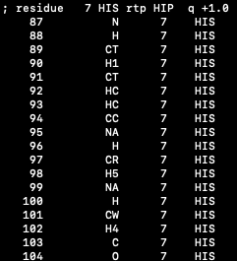

you would need to change HIS in the fourth column to HID, HIE, or HIP in order for the force field parameters to be converted properly for histidine.

**RSFF2 and D-Val**

**Note: If you are using any D-Valine amino acids, you must check that your structures are being generated correctly due to this RSFF2 Idiosyncrasy.**

RSFF2 modified two dihedrals: 𝛘1:  N – CA – CB – CG2, 𝛘1’: C – CA – CB – CG2 on CG2, but not on CG1. When build D-Val in Chimera, this should be paid attention to, as it is not enough to issue only “invert :ResID@ca” on the L-Valine residue to build a D-Valine. One should issue both “invert :ResID@ca” and “invert :ResID@cb”, also to switch CG1 and CG2. Specifically, in the file chimScriptMaker.py of genInit2.5, one should add two more lines (underlined in the figure below):

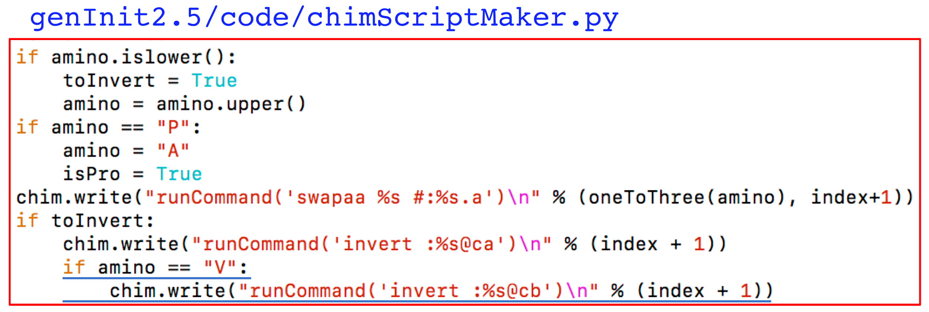

In “genInit3.0”,it appears that these lines of code have been added, however you should check to make sure that this case of D-Valine is handled correctly.